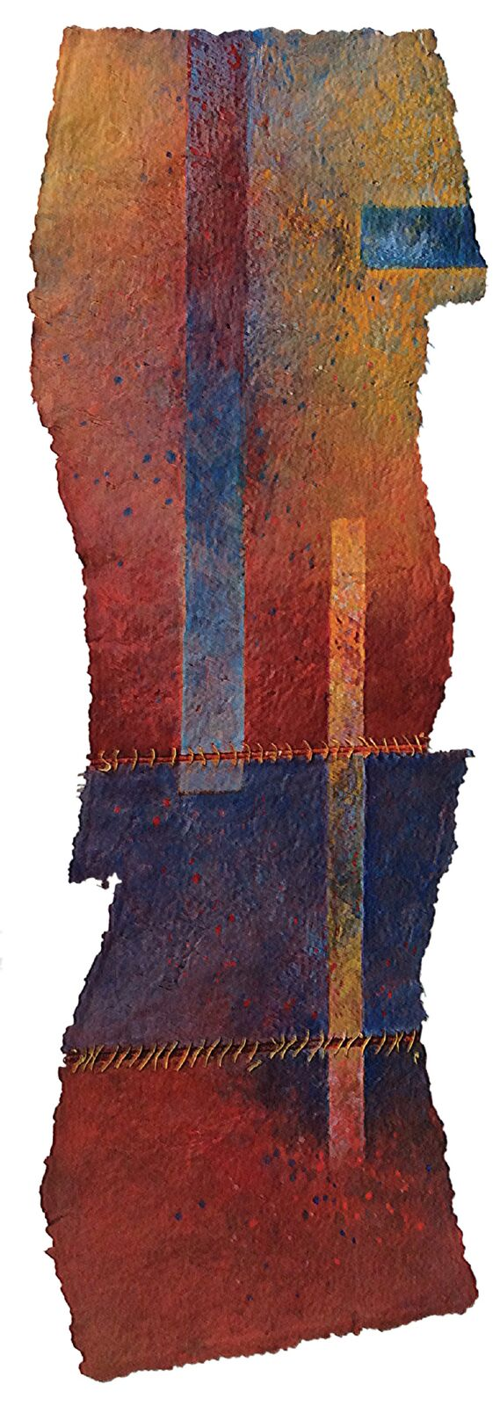
‘Crossing Boundaries’
A Commemorative Exhibition of Artwork by
Carol Farrow
(1944-2012)

22nd September-8th October 2017
The Jointure Studios, Ditching, Sussex
Many art lovers are already admirers and devotees of Carol’s innovative work: she is recognised as the gifted maker of stunningly beautiful and compelling wall-hung Paperworks. Her intriguing and delicate sculptural objects in Paperclay are less well known, even though she had used the material since inventing it in 1981. This commemorative exhibition of her remaining works at Jointure Studios in Sussex will celebrate her mastery of colour and texture, her joy in form and materials, and introduce her unique art to a new audience. All art works will be for sale.

Why the title ‘Crossing Boundaries’?
For several reasons: firstly, and mainly, because Carol crossed the conventional divide between Fine Art and Craft. She combined her exceptional artistic talents with experimental enquiries into the materials she used, making innovations in painting, ceramics and fibre art, becoming well known for her brave and pioneering spirit. Secondly, she established studios in both England and France. Thirdly, she had an international exhibition schedule which included Europe, America, Turkey and China. And finally, having invented Paperclay in 1981, and advanced handmade paper as a medium for artists, she became a passionate ambassador for both, sharing her love of them with students in several European countries, Israel and India.

Paperworks: Texture, Colour, Format
Her handmade paper was made specifically for her paintings (Paperworks) allowing her control over their size and shape, as well as their surface and edge qualities. Her colour sense was infallible, and whether delicate or robust, it always imbued her works with emotional resonance. By adopting the unusual diptych and triptych formats she added dynamic rhythm to her large-scale composite works. Heavily stitched ‘hinges’ formed knotty features that punctuated a variety of contrasting surface textures, enhancing their strong physical presence. Viewers found the work fascinating, with qualities redolent of leather or metal, and charged with an irresistibly beautiful luminosity.

Paperclay: a new ceramic material
She invented Paperclay out of a desire to make light, large-scale ceramic wall panels. This material has since had a major, global impact in the world of ceramics. In 1987, The Artist’s Newsletter published her account of the birth of the material. She later developed sculptural forms derived from kitchen utensils. Bitters.Co, a Seattle gallery exhibiting them, said this: ‘her work is beautiful, full of warmth and incredible textural character’.
Inspiration: things changed by time, use and weather.
Carol’s wall-hung Paperworks were often inspired by architectural features changed by weathering, ageing, use, repair or alternative function. Working in France amongst the old local stone buildings she made direct paper casts of carved windows and lintels, decrepit wooden doors and shutters, worn floorboards and garden tools deformed by years of use. These casts became poignant low-relief painted paperworks that recalled a bygone lifestyle.
Her sculptural Paperclay objects also referenced the past: the material was perfect for capturing the scratched, ‘found’ and ‘friendly’ qualities of surfaces on utensils changed by the effects of use. Some pieces were impressed with fabric or metal to evoke the ‘memory’ of such articles. In addition, she enjoyed the interaction between the forms and often made composite or grouped works. Loving old linen sheets, clothes, and ticking, she made a contribution to Fibre Arts with wittily constructed tinted collages using a different vocabulary of shapes and quiet surface textures alluding to other lives already lived.

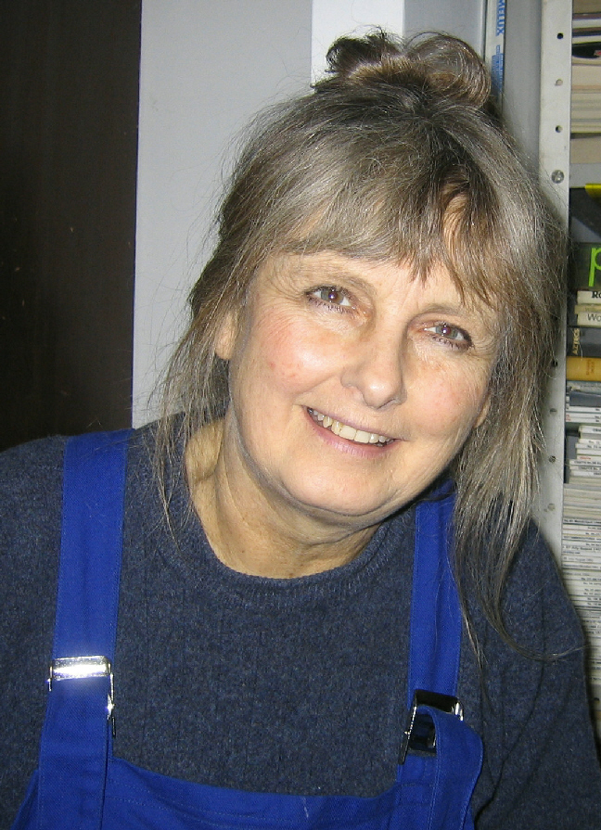
Teaching: a generous and open attitude
A deeply committed and inspirational teacher, she gave freely of her knowledge and ideas to the many students that made their way to her courses from far and wide. She taught both her papermaking and paperclay processes to hundreds of appreciative students over the years. They learned of her concerns about conservation and environmental issues. Sculptor Alison Simpson says ‘I hope one day my work will live up to her input, and I’m sad that I won’t be able to show it to her. Let today be Carol Farrow Day - I’m off to the studio’.
Her friend, fellow maker and ‘The Basketry Garden’ blogger Stella Harding says ‘Carol was a gifted artist, teacher and mentor with a most kind and generous spirit: her garden, the legacy of a creative life with not one moment wasted, will always be full of flowers’.
Editor’s Note
Venue: The Jointure Studios, 11 South Street, Ditching, Sussex BN6 8UQ
Exhibition open: 11am-5.30pm Friday, Saturday & Sunday
22nd September-8th October 2017
Further information:
Email contact: martin-ward@wanadoo.fr
Phone contact: Shirley Crowther 01273 841244
Web: www.jointurestudios.co.uk or www.carolfarrow.net

